S23-0074_Email Only_Local 1000 Backgrounds for Solidarity
How to Add a Custom Background
rev 03.10.2023

Add a custom background to Teams Meetings

Prior to the Teams meeting, save your custom background files (or a photo) to your desktop or an area where you will remember.

Once in the meeting, click the three dots above “More”

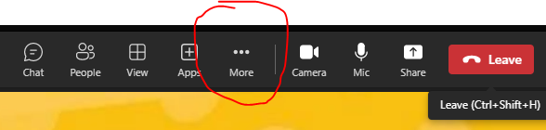

Click on Background Effects

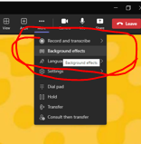

Click Add New

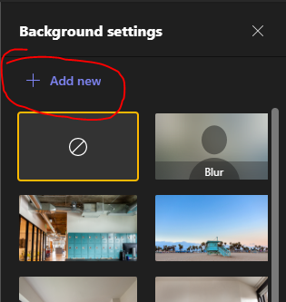

Look for the files you saved earlier and click on the one you want to display (this is just like adding an attachment to an email)

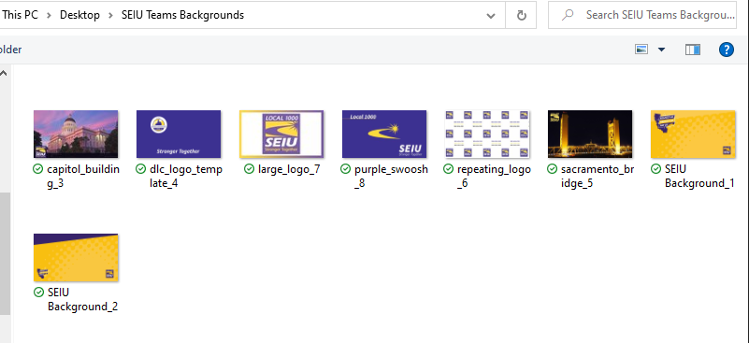

After selecting your file, you will be sent back to the Teams meeting. You will have to click on the three dots above More again.

Click on Background Effects again

Once you select your background, click the Apply button
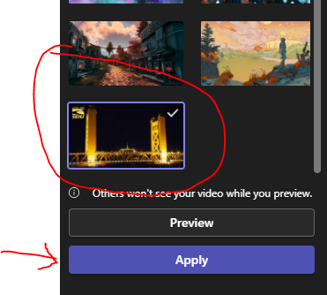

Enjoy!!

